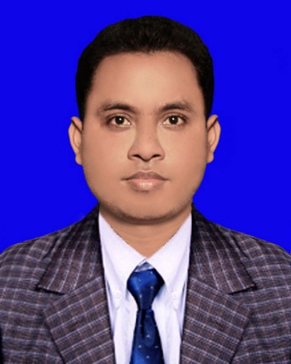 **RESUME**

OF

Md. Anamul haque

**Contact Address:**

Boro-Baluakandi,

Gazaria,Munshigonj

Contact: +8801746070644

E-Mail: [haque1338@gmail.com](mailto:haque1338@gmail.com)

* **Objective:**

To make and excellent career on **Mechanical Technology** based on job as an Engineer.I would like to build an excellent career which has a challenging position and which is rapidly expanding and offers good advancement potential.

* **Diploma in Engineering (4 year):**

Institution : Comilla Polytecnic Institute

Board : Bangladesh Technical Education Board,Dhaka

Depertment : Mechanical

CGPA Result : 2.95 (Out of 4.00)

Session : 2014-15

* **Secondary School Certificate (S.S.C) :**

Institution : Burail High School and Collage,Gaibandha

Board : Dinajpur

Group : Science

Grade Point : 3.81 (Out of 5.00)

Passing Year : 2014

* **COMPUTER COMPITANCE:**
* MS Word, MS Excel & Power Point
* Auto Cad,2D
* Internet Browsing
* **PERSONAL SKILLS:**
* Sincerity and Honesty.
* Ability to handily critical situation.
* Self-Motivated and hard working.
* Comfortable at working in group & individually.
* Leading any Group of work & assignment
* LEARNING SKILLS:
* Good command and is Writing Both in English & Bengali.
* **PERSONAL INFORMATION:**

Name : Md.Anamul haque

Father’s Name : Md.Abubkkar Siddiq

Mather’s Name : Most. Renuka Begum

Religion : Islam

Sex : Male

Maritial Status : Unmarried

Date of Birth : 13 November 199

Natinal Id No : 6454546042

Hight : 5'.5''

Weight : 64 kg

* **Permanent Address:**

Village : Porchim chaluya

Post Office : Uddakhali

Upozilla : Fulchari

Gistrict : Gaibandha

* **EXPERIENCE:**

|  |  |  |  |  |
| --- | --- | --- | --- | --- |
| Company Name | Designation | Section | Joint Date | Experience |
| Sinobangla Industries Limited | Production Supervisor | Manual Fibc | 25.06.2018 | 1 Year 6 Month |

* **Trade Course:**

|  |  |  |
| --- | --- | --- |
| Trade Name | Organization Address | Duration |
| Computer Office Application | Linax Computer Traning Center (133) | 06 Month |
| Weldinng & Fabrication | TTC,Comilla | 06 Month |
| Micro Driving | TTC.Comilla | 03 Month |

* **Industrial Attachment:**
* I have successfully Completed 03 Months Industrial Traning at "BITAC" Tajgoan I/A,Dhaka-1208.

* **Reference:**

Md.Yousuf Rana (Suvo) Khobirul Haque

Sub-Assistant Engineer Instracktor

Sinobangla Industries Limited Comilla Polytecnic Institute

Mobile: 0191946339

Mobile: 01715348825

* **Declaration:**

I declare all the information inciuded hare are true to my Knowledge. If required and where applicable , this document can be supported by appropriate authentic certificates.

Date: Md.Anamul haque